Gene Expression
Integrative Survival Analysis of Breast Cancer with Gene Expression and DNA Methylation Data
Isabelle Bichindaritz¹, Guanghui Liu^{1,*}, and Christopher Bartlett¹
¹Department of Computer Science, State University of New York at Oswego, New York, USA
*To whom correspondence should be addressed.
Associate Editor: XXXXXXX
Received on XXXXX; revised on XXXXX; accepted on XXXXX
Abstract
Motivation: Integrative multi-feature fusion analysis on biomedical data has gained much attention recently. In breast cancer, existing studies have demonstrated that combining genomic mRNA data and DNA methylation data can better stratify cancer patients with distinct prognosis than using single signature. However, those existing methods are simply combining those gene features in series and have ignored the correlations of each single task over time.
Results: In the present study, we propose an adaptive multi-task learning method for survival prediction of breast cancer patients using multi-modal learning instead of performing survival analysis on each feature data set. First, we use local maximum quasi-clique merging (lmQCM) algorithm to reduce the mRNA and methylation feature dimensions and extract cluster eigengenes respectively. Then, we build an ordinal cox hazards model for survival analysis and use long short-term memory (LSTM) method to predict patients’ survival risk. We add an adaptive auxiliary ordinal loss to the original Cox model to improve the ability of optimizing the learning process in training and regularization. It helps to reduce the vanishing gradient problem for earlier layers and helps to decrease the loss of the primary task. We use the cross-validation method and the concordance index (C-index) for assessing the predicting effect.. Stringent cross-verification testing processes for the benchmark data set and two additional datasets demonstrate that the developed approach is effective, achieving very competitive performance with existing approaches.
Keywords: Survival analysis, Breast cancer, Gene expression, DNA methylation, Ordinal cox model, Multi-task learning.
Availability and implementation: https://github.com/bhioswego/ML_ordCOX
Contact: guanghui.liu@oswego.edu, ibichind@oswego.edu
Supplementary information: Supplementary data are available at Bioinformatics online.

- Introduction
Breast cancer has been one of the most common form of diseases worldwide. Reported data emphasize the importance of a more profound understanding of the factors that trigger breast cancer and contribute to its development. Gene expressions driven by many elements receive frequent application to be marking elements of breast carci-noma progression. 2 factors easy to measure refer to DNA methyla-tion and mRNA expressing process. DNA methylating process and mRNA levels exhibit differential expressions in a variety of tissues (Suzuki, et al., 2012). For elucidating the interacting process of various genomics-related characteristics, more sophisticated modeling and analyzing process is required. It is noteworthy that the causal associations of DNA methylating process information and gene expression data receive wide analyses (Anjum, et al., 2014; Jiao, et al., 2014; Yang, et al., 2014). Methylation’s and mRNA’s influence in cancer have been introduced with great success. mRNA epigenetic regulating process via DNA methylation at CpG sites can be maintained, with methylating patterns termed as epigenetic markers (Lobo, 2008).
In early studies on cancer prognosis, the use of single-feature biomarkers were often noticed. Yet in the mentioned researches, some useful supplementary information between different data modalities was ignored. With the advances of modern genomic technologies, integrative analysis on heterogeneous data to find important information for diagnosis, staging, and prognosis for cancers has received considerable attention (Jeong, et al., 2015; Kim, et al., 2016; Kim, et al., 2018). Multi-features fusion analysis is receiving widespread application by pathologist in practical clinics-related affairs. Some studies have explored a combination of different genomic biomarkers for survival analysis. ((Kim, et al., 2018) proposed an integrative robust pathway-based directed random walk (DRW) method on surviving predicting process of breast carcinoma utilizing the interaction of gene expressing state and DNA methylating process. (Yuan, et al., 2012) integrated image and genomic records for improving the surviving prediction of breast cancer cases. (Cheng, et al., 2017) constructed an emerging framework capable of predict-ing the surviving outcome of renal cell carcinoma cases by combining image features and gene expression features. As indicated by the mentioned existing researches, different forms of data complement with each other and present more effective case stratification if employed jointly. Though the combination of genomic features are capable of more effectively predicting the clinical prediction of carcinoma cases, simple combination of the mentioned characteristics are likely to present redundant characteristics, thus reducing the predicting effect, so features selecting process is critical to multimodal feature fusion. In previous research, the multimodal data were commonly linked, and subsequently the conventional features selecting approaches were adopted for selecting the parts associated with carcinoma prediction.
In clinical practice, pathologists make a diagnosis and predict prediction by clinical exam. The clinics-related behaviors of breast carcinoma are significantly diverse, covering aggressive metastatic disease and slowly developing localized tumors (Gulati, et al., 2014). Thus, prediction-related marking elements are critical to split cases for personalized carcinoma management, which could avoid over treatment or under treatment (Chen, et al., 2015). For example, those patients classified as high-risk groups may benefit from more aggressive therapies, closer follow-up and more advanced care plans (Kim, et al., 2004; Yu, et al., 2016). Cox proportional hazard model (Lin, et al., 1993) is one of the most popular survival prediction model. Recently, based on the Cox model, several regularization approaches have been proposed in the literature. The Least Absolute Shrinkage and Selection Operator COX model (LASSO-COX) (Ryall, et al., 2017; Shao, et al., 2018; Tibshirani, 1997) apply lasso feature selection method for selecting parts associated with carcinoma prediction. Random survival forests (RSF) (Ishwaran, et al., 2008) calculates a random forest with the log-rank test to be the splitting standard. It determines the cumulative hazards of the leaf nodes while averaging them over the total elements. Cox regression with neural networks by a one hidden layer multilayer perceptron (MLP) (Xiang, et al., 2000) was proposed to replace the linear predictor of the Cox model. Some novel networks were suggested to be capable of outperforming typical Cox models (Amiri, et al., 2008). DeepSurv (Katzman, et al., 2016; Katzman, et al., 2018) ] refers to a deep Cox proportional hazards neural network as well as a surviving approach to model interacting processes of a cases’ covariates and treating efficacy for providing individual treating suggestions. DeepSurv is developed upon Cox proportional assumption with the cutting-edge deep neural network. MTLSA (Li, et al., 2016) is the recently proposed model which regards surviving study to be a multi-task learning issue. It transforms the problem into several binary classifying processes, and employs a multi-task learning approach to model the event probability at different time. Though much progress has been made using above approaches, Yet the predicting performance of the previously proposed approaches remains far from satisfying, and huge place remains for subsequent advancement. In addition, the mentioned approaches assumed that the surviving data of one patient is not determined by another, thereby losing the robust ordinal association of the surviving times of a range of cases.
Motivated by all the mentioned considerations, we present a novel method for survival prediction of breast cancer using bidirectional Long Short-Term Memory (biLSTM) (Hochreiter and Schmidhuber, 1997) Cox model network and multi-task learning from gene mRNA and DNA methylation multi-modal data. The losses of auxiliary tasks added to the original objective help to improve the ability of optimizing the learning process in biLSTM training and regularization. Because the performance of multi-task systems strongly depends on the relative weight between the losses of each task, adjusting these weights manually is a difficult and expensive process, which makes multi-task learning difficult in practice. So, we use an adaptive approach to multi-task learning which weighs multiple loss functions by considering the homoscedastic uncertainty of each task. This allows us to learn all kinds of quantities in the regression settings of different units at the same time. This study demonstrates the effective properties of the developed approach through cross validation tests on the benchmark dataset..
- Materials and Methods
  - Benchmark Datasets
In this study, the used survival analysis benchmark datasets include gene expression data, DNA methylation data, and clinical data. The clinical data are included in the main clinical file downloaded from The Cancer Genome Atlas (TCGA) (Tomczak, et al., 2015), which provides an extensive collection of genomics and clinical outcome data for large cohorts of patients of more than 30 types of cancers. The main files contain 1097 breast cancer patients’ clinical annotations and information. In our case, two clinical variables are used: Overall Survival Status (1 if the patient deceased, 0 if he/she is living at the time of the last follow-up) and Overall Survival (Months), which represent the number of months between diagnosis and date of death or last follow-up. In clinical data, patients with missing follow-up were excluded.
The genes expressing data and DNA methylation data of breast cancer cases pertain to the TCGA data set of the Broad Institute GDAC Firehose (Deng, et al., 2017). Genes expressing information from mRNA sequence consisted of 20,533 genes. mRNA expression profiles re-ceived the transformation from Illumina HiSeq 2000 RNA-seq readcounts to normalized reads per kilobase per million (RPKM). This study acquires DNA meth-ylation data as a gene-related characteristic of 20,106 genes through the selection of the probe exhibiting a minimal relation to expressing information for the respective gene. This study removes genes achieving genes expressing values of 0. Gene expression data, DNA methylation data and clinical data were merged and filtered to keep matching. This study removes cases with survival months not recorded or not correctly to be the negative data. For the mentioned reason, among 1097 cases, this study extracts 485 instances that had both mRNA sequencing and DNA methylating information. The benchmark dataset including gene data and survival data was obtained. Table 1 lists the gene and clinics-related features for the taken cases.
A challenging point facing the present research is that other significant cohorts of breast cancer with matched DNA methylation and gene expression information are insufficient. Thus, this study firstly applies cross-validating process in the respective step of downstream of the machine learning research, then adopts a second data set to validate the efficacy of the proposed method.
Table 1. Gene and clinical characteristics of breast cancer.
Characteristics | Summary
Instance no. | 485
Gene no.
Methylation | 20106
mRNA | 20533
Survival status
Living | 413
Deceased | 63
Follow up (months) | 0.03-282.69
Age (years)
Range | 26-90
Median | 57.23

  - Gene feature extraction
The large number of genes of mRNA and methylation posed a challenge to obtaining sufficient statistical power. Recently, A weighted network mining algorithm termed as local maximum quasi-clique merging (lmQCM) (Cheng, et al., 2017) has been developed and receives well application in gene co-expression research. lmQCM could detect weak quasi-clique modules in weighted graphs with application in functional gene cluster discovery This algorithm is a greedy approach that uses hierarchical clustering and does not allow overlap between modules, Meanwhile, it allows genes to be shared among multiple modules. This is consistent with the fact the genes often participate in multiple biological processes. In addition, lmQCM can find smaller coexpressed gene modules that are often associated with structural mutations such as copy number variation in cancers. Another well-known gene clustering algorithm is weighted gene co-expression network analysis (WGCNA) (Langfelder and Horvath, 2008). WGCNA is a powerful technique used to extract co-expressed gene networks from gene expressions, and is widely used in genomic data analysis.
In our study, we tested the effectiveness of methods of lmQCM and WGCNA respectively. By comparing the effects, we chose lmQCM as gene feature extraction method. Instead of focusing on individual genes, we firstly use the lmQCM algorithm to cluster genes into coexpressed modules, then summarized each module as an eigengene. The lmQCM algorithm has four parameters γ, t, α, β. Among these parameters, γ is the most influential, as it determines if a new module can be initiated by setting the weight threshold for the first edge of the module as a subnetwork. In the lmQCM algorithm, the absolute values of the spearman correlation coefficients between expression profiles of genes are transformed into weights using a normalization procedure adopted from spectral clustering. Thus, lmQCM algorithm yields 33 coexpressed gene modules (features) for methylation data and 120 coexpressed gene modules for mRNA data. It is worth noting that to avoid overfitting, we applied gene feature selection methods to the training set and test set in cross validation respectively.
  - Ordinal Cox model
In survival analysis, prediction of the time duration until a certain event occurs is the goal of survival analysis and the death of a cancer patient is the event of interest in our study (Kourou, et al., 2015). Cancer patients in our study can be divided into two categories i.e., censored patients and non-censored patients. For censored patients, the death events were not observed for them during the follow-up period, and thus their genuine survival times are longer than the recorded data; while for non-censored patients their recorded survival times are the exact time from initial diagnosis to death. We use a triplet $(x_{i},t_{i},δ_{i})$ to represent each observation in survival analysis, where $x_{i}$ is the feature vector, $t_{i}$ is the observed time, and $δ_{i}$ is the censoring indicator. Here, $δ_{i}=1$or $δ_{i}=0$indicates a non-censored or censored instance, respectively.
The primary goals in survival analysis are estimating the survival function and hazard function (Wang, et al., 2019), both of which can be used to model the distribution of the event time over the timeline. Survival function $s(t|x)$ represents the probability that the event has not happened earlier than a specified time t (Lee and Wang, 2003). We define O as the variable of the true occurrence time for the event of interest and $P_{r}(O)$ is the probabilistic density function (P.D.F.) of the true event time. So we have,
$s(t|x)=P_{r}(O≥t|x)$ (1)
By defining the survival function $s(t|x)$ as the probability that a patient will survive after time t, the hazard function that can assess the instantaneous rate of death is defined as following:
$h(t|x)=\lim_{Δt→0}\frac{P_{r}(t≤O≤t+Δt|O≥t;x)}{Δt}$ (2)
Where $x=(x_{1},x_{2},⋅⋅⋅,x_{n})$ corresponds to the covariate variable of dimensionality n. Among the hazards modeling methods, cox proportional hazard model (Lin, et al., 1993), which is built based on the hypothesis that the hazard ratio between two instances is time-independent, is defined as:
$h(t|x)=h_{0}(t)\exp{(}θ^{T}x)$ (3)
Here, $h_{0}(t)$ is the baseline hazard, and $θ^{T}x_{i}$ is called survival function, in which $θ=(θ_{1},θ_{2},⋅⋅⋅θ_{n})$ can be estimated by minimizing its corresponding partial likelihood function. The partial likelihood is defined as follows:
$L(θ)=\prod_{i:δ_{i}=1}{\frac{ \begin{matrix}\exp{(}h(t_{i}|x_{i})) & \end{matrix}}{\sum_{j∈R(t_{i})}{\exp{(}h(t_{j}|x_{j}))}}}$ (4)
Where T_{i} denotes the event time, $δ_{i}$ is a binary value indicating whether the event happened or not, and$R(t_{i})$ denotes the set of all individuals at risk at time$t_{i}$, which represents the set of patients that are still at risk before time$t_{i}$. Therefore, the coefficient vector can be learned via minimizing the negative partial log-likelihood function of the Cox model, which is defined as following (Sy and Taylor, 2000):
$L_{Z}(θ)=-\sum_{i=1}^{n}{δ_{i}}\left(θ^{T}x_{i}-\log{\sum_{j∈R(t_{i})}{\exp{(}θ^{T}x_{j})}}\right)$ (5)
Although we could use the above Cox model to directly make survival prediction, it does not take the ordinal survival information between different cases (e.g., the survival time for case A is longer than that for case B) into consideration. In the hazard ratio based model, the ordinal relationship of the hazard risk between patient $i$and patient $j$can be easily derived by calculating the ratio (i.e., rec_{ij}):
$rec_{ij}=\frac{h(t|x_{i})}{h(t|x_{j})}=\frac{h_{0}(t)\exp{(}θ^{T}x_{i})}{h_{0}(t)\exp{(}θ^{T}x_{j})}=\exp{(}θ^{T}(x_{i}-x_{j}))$ (6)
In practice, if$rec_{ij}≥1$, the survival time for patient$i$should be shorter than that for patient$j$, and vice versa. By utilizing the above ordinal relationship indicated by Cox model, we design a ranking loss function to capture the ordinal survival information among different patients as follows:
$$ordLoss=-\sum_{i=1}^{n}{\sum_{j≠i}{I*\max{(}0,1-rec_{ij}}})$$$=-\sum_{i=1}^{n}{\sum_{j≠i}{I*\max{(}0,1-\exp{(}θ^{T}(x_{i}-x_{j}}}))$ (7)
Where I = 1 if the survival time for patient$i$is shorter than that for patient$j$. Otherwise, I = 0.
By combining the Cox negative partial log-likelihood function L_{Z} with the above ordinal loss ordLoss, the weighted sum of the losses can be formulated as a multi-task model. Numerous existing approaches learning many tasks in the meantime employ a naive weighted sum of losses, in which the loss weights are uniform, or altered in a crude and manual manner. However, the model effect exhibits extreme sensitivity to weight selecting process. The mentioned weight hyper-parameters can be tuned at high costs. Thus, a more convenient approach capable of learning the optimal weights is required. We develop a method to integrate several loss functions for learning some objectives in an adaptive manner.
  - Adaptive weighting losses
In this study, we used methylation or gene expression features to make survival predictions for breast cancer patients. Our main task is obtaining the training model. The main task has a corresponding loss L_{main}, which can be the expected return loss used for calculating policy gradient. The present study employs the Cox negative partial log-likelihood function as the main loss L_{mian}, i.e. L_{main}=L_{Z}. To improve data efficiency, besides the main task, one has access to one or more auxiliary tasks that share some unknown structure with the main task (Papoudakis, et al., 2018). Here, the ordinal loss can be used as auxiliary loss of an auxiliary task, i.e. L_{aux}=ordLoss. Our goal is to optimize the main loss L_{mian}. However, auxiliary tasks are commonly used to help to learn a good feature representation. We can combine the main loss with the loss from the auxiliary tasks as:
$L(θ,λ_{1},λ_{2})={K_{1}(λ}_{1})L_{main}(θ)+{K_{2}(λ}_{2}{)L}_{aux}(θ)$ (8)
where $θ$ is the set of all training model parameters, $and K_{1},K_{2}$are the weights for the main task and the auxiliary task respectively. Let $K_{i}(λ_{i})=e^{-λ_{i}} (i=1,2)$, in which $λ_{1}$,$λ_{2}$are the weight variables with an initial value of 0. Under the intuition that modifying$θ,λ_{1},λ_{2}$to minimize$L$will improve $L_{main}$and $L_{aux}$if the two tasks are sufficiently related. We propose to modulate the weight variable $λ_{1},λ_{2}$ at each learning iteration (epoch) $t$by adding a custom-multi-loss layer in the deep network. Given$θ_{t}$ is the set of all model parameters at training step $t$, and${ λ}_{1t}$,$λ_{2t}$are the weight variables at step $t$. We assume that we update the parameters$θ_{t}$, $λ_{1t}$, and $λ_{2t}$using gradient descent on this combined objective:
$$θ_{t+1}=θ_{t}+α∇_{θ_{t}}L\left(θ_{t},λ_{1t},λ_{2t}\right)$$
$$λ_{1(t+1)}=λ_{1t}+α∇_{λ_{1t}}L(θ_{t},λ_{1t},λ_{2t})$$${ λ}_{2(t+1)}=λ_{2t}+α∇_{λ_{2t}}L(θ_{t},λ_{1t},λ_{2t})$ (9)
Where$α$is the gradient step size. At each optimization iteration, we can efficiently approximate the solution to $\underset{}{argmin(L})$. The weights are discouraged from decreasing too much by the negative exponential functions. The modelling task-dependent weighting can improve the model’s representation and the performance of each task when compared to separate model trained on each task individually.
Flowchart of system algorithm
Figure1 shows the algorithm process of our proposed method. There are several stages including the gene co-expression cluster stage, main/auxiliary biLSTM network stage and the COX model stage etc. In the gene co-expression cluster stage, the feature dimensions of the mRNA and methylation data could be reduced. lmQCM algorithms are used to cluster genes, and so mRNA and methylation eigengenes are obtained respectively. The directly concatenated eigengenes of mRNA and methylation will be main task input features for the machine learning network to train the model. Meanwhile, we also use the concatenated eigengenes as auxiliary task input. In the main task, multiple biLSTM layers, timeDistributed layers, dropout layers, and full connected layers are used to predict patient survival risk with the negative partial log-likelihood function, and then the main loss (i.e., L_{main}) is obtained. In the auxiliary task, we use one auxiliary biLSTM layer and one full connected layer to obtain the ordinal loss (i.e., auxiliary loss L_{aux}). We designed a custom multi-loss layer which can combine the main loss with the auxiliary loss: ${K_{1}(λ_{1t})L}_{main}+{K_{2}(λ_{2t})L}_{aux}$at each learning iteration t. We use a proposed adaptive optimization iteration method to tune the weight variables (λ_{1t}, λ_{2t}) of the main and auxiliary loss. Finally, through iterative training, the deep cox hazard model is built for survival analysis to ensure that the ordinal relationship among the survival time of different patients can be preserved. We termed this multiple losses ordinary COX model procedure as ML_ordCOX.

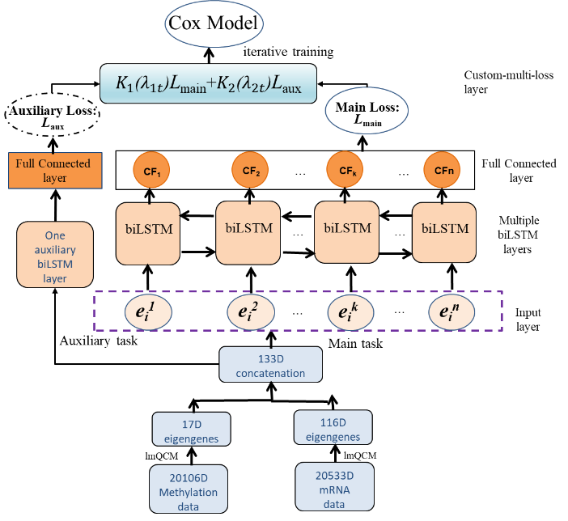
Figure 1. Illustration of the proposed model and framework.
  - Evaluation indexes
This study assesses the performance of the developed approach and other comparing method using Concordance index (C-index). C-index quantifies the fraction of all pairs of cases with predicted survival times ordered in a correct manner as:
$C-index=\frac{1}{\left|k\right|}\sum_{i=1}^{m}{\sum_{j:t_{i}<t_{j}}{I(F(x_{i}})<F(x_{j}))}$ (10)
Where k denotes the set of validly orderable pairs when t_{i}<t_{j}; represents the number of comparable pairs among them; (𝑥) is the prediction of survival time; 𝐼 is the indicator function of whether the condition in parentheses is satisfied or not. C-index gives probability. In terms of a random individual pair, the predicted survival time of the two individuals is in the same order as their actual survival time. Since the C-index is determined only by variations in the predicted results, it is very useful for evaluating proportional hazard models. Because the order of proportional-risk models doesn't change over time. Therefore, we were able to use relative risk functions rather than measures used to predict survival time.
k
- Results and Discussions
  - Coexpressed gene modules clustering help to improve prediction accuracy
In this section, we tested three gene feature selection methods: Denoising Autoencoder (DA) (Liu, et al., 2019), lmQCM, and WGCNA. DA has proven to be effective in selecting robust features against input noise and extracting more specific cancer-related pathways or genes. We set the number of DA encoder layer nodes as 100, and activation function as 'sigmoid'. In lmQCM, we set parameters with γ=0.30,t=1,α=1, β=0.4, and γ=0.30. To WGCNA, we set minModuleSize=30. Through these three different methods, methylation and mRNA features after dimensionality reduction can be obtained. We use DA algorithm to obtain 100 methylation features and 100 mRNA features respectively. We use lmQCM algorithm to obtain 17 methylation features and 116 mRNA features respectively. Similarly, we use WGCNA algorithm to obtain 12 methylation features and 26 mRNA features respectively. We combine methylation and mRNA features in series and obtain 200, 133, and 38-dimensional features in three different methods. We test each integrated feature and compare performance between different methods with C-index value. Table 2 lists the performance comparison of three methods. For the sake of fairness and convenience, we only carry out the same single task loss function, i.e. main loss (L_{main}), and the same biLSTM structure.
As shown in Table 2, it can be found that lmQCM and WGCNA methods have better performance than DA. In the cross validation on the standard data set, lmQCM is superior to WGCNA. Compared with the DA and WGCNA methods, the C-index of lmQCM is improved by 11.08% and 1.19%. Considering the similar computational complexity of lmQCM and WGCNA, we decided to adopt lmQCM method to extract gene features.
Table 2. Comparison of performance of three gene feature selection methods with C-index.
Gene Selection Methods | C-index
DA | 0.5348
WGCNA | 0.6337
lmQCM | 0.6456
  - Multi-feature fusion is superior to single feature set
In this section, this study assesses the performance concerning the inte-grated feature set with different single feature set. After obtaining 116 mRNA eigengenes and 17 methylation eigengenes from lmQCM algorithm respectively, we take the two eigengenes as two different single gene feature (named G_{mRNA} and G_{meth}) inputs. We combine mRNA and methylation features in sequence and obtain a 133-dimensional feature vector which will be viewed as integrated gene feature (Named G_{mRNA+meth}) input. Moreover, for the sake of fairness, this study carries out the same multiple losses ordinary COX model procedure (i.e. ML_ordCOX). The experiments compare the performance of three feature sets over ten-fold cross validation and run 1000 iterations. It should be noted that the learning rate will be set with an initial value of 0.001, and will be reduced by half every 100 epochs during training phase in order to improve model performance. Table 3 summarizes the performance comparison of the three feature sets with the values of the C-index.
Table 3. Performance comparison among integrated feature set and single feature sets with C-index.
Feature Sets | C-index
G_{mRNA+meth} | 0.6945
G_{mRNA} | 0.6707
G_{meth} | 0.5573

As demonstrated in Table 3, in the 10-fold cross validation on standard data sets, the G_{mRNA+meth} outclasses the two single feature sets. Compared with them, G_{meth} and G_{mRNA}, the C-index of the G_{mRNA+meth} is improved by 2.38% and 13.72%. The integrated feature, by leveraging the combination of the single feature, can effectively improve the performance.
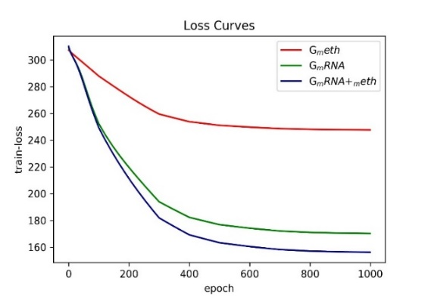
Figure 2. The training loss curves by applying different feature sets.
Figure 2 reflects the loss decrease during training phase by applying different feature sets. From the figure, we found that as the number of iterations increases, the training loss of the multi-feature fusion methods (G_{mRNA+meth}) decreases obviously faster than that of the other two single feature set methods (i.e., G_{meth} and G_{mRNA}). The faster gradient descent helps the training loss converge to the optimal solution. It demonstrates the advantage of the integrated patterns of sequential mRNA data and methylation data. It is worth noting that the continuous decay of the learning rate makes the training loss curve finally converge.
  - Multi-task losses method performs better than only single task loss
We compare the proposed multi-task losses method (i.e. ML_ordCOX), which combines the main loss (L_{main}) with the auxiliary loss (L_{aux}) from the auxiliary task, with two only single task loss methods (i.e. only main task loss and only auxiliary task loss). In 3.2 section experiments, G_{mRNA+meth} is the best feature. So, we use G_{mRNA+meth} as input feature set to assess the performance concerning the proposed approach. Table 4 presents the performance comparison of the ML_ordCOX and the two single task loss methods with the values of the C-index. Figure 3 shows the training loss curves of three different loss methods.
Table 4. Performance comparison between two different loss methods with C-index.

Methods | C-index
Multi-task losses (ML_ordCOX) | 0.6945
Only main task loss | 0.6456
Only auxiliary task loss | 0.5056

From Table 4, we can find that the multi-task ML_ordCOX method has the best performance than the other two single task methods. Compared with only main task loss and only auxiliary task loss, the C-index of the ML_ordCOX is improved by 4.89 percent and 18.89 percent. It means that the proposed multi-task method can dynamically adapt the weights for the multiply tasks to perform better than or as well as the best single task. As can be seen from this Figure 3, the curve of the only auxiliary task loss method converges fastest, and the curve of the multi-task method ML_ordCOX, which combines the two single tasks, decreases faster than that of the only main task. It indicates that the auxiliary task will help multi-task to converge to the optimal solution if we add an auxiliary loss term to the total loss function.

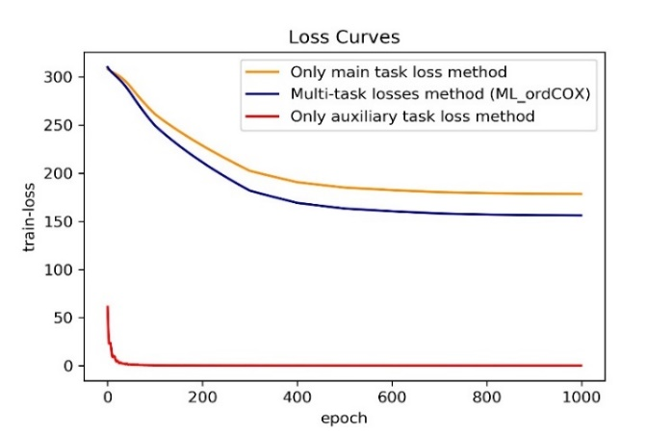
Figure 3. The training loss curves of three different task loss methods
We developed an adaptive optimization iteration method to tune the weight variables (λ₁, λ₂) of the main and auxiliary loss. In the experiments, we also tracked the weight variables and got the curve of weight change. Figure 4 shows the curves of weight variables $(λ_{1}$,$λ_{2})$, (i.e. lambda1, lambda2), and weights $(K_{1},K_{2})$ for the main task loss and the auxiliary task loss. Here, $K_{i}\left(λ_{i}\right)=e^{-λ_{i}},(i=1,2)$. In Figure 4 (a), weight variables $(λ_{1}$,$λ_{2})$are set with initial value of (0,0), and the values are almost unchanged when the model converges. As also can be seen from Figure 4 (b), weights $(K_{1},K_{2})$ are set with initial value of (1,1) and converge to (0.8617, 0.9871) when 1000 epochs are completed. As demonstrated in figures, Firstly, we could use the negative exponential functions of weight variables to effectively discourage the weights from decreasing too much. Secondly, compared with auxiliary task, the weight of main task plays a major tuning role in training multi-task model.

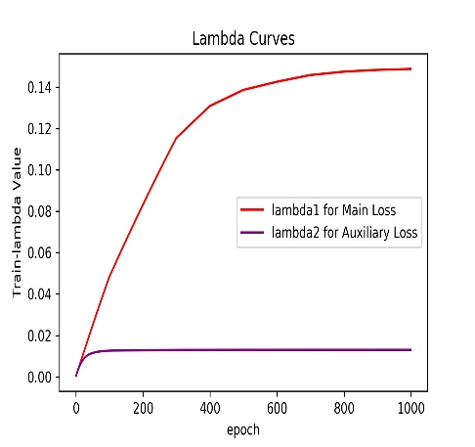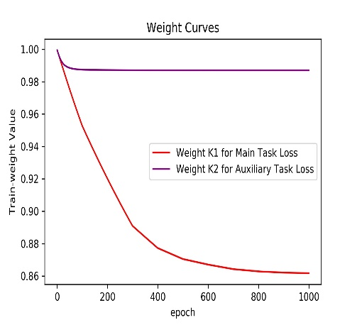
- (b)
Figure 4. The weight variable and weight curves of main task loss and auxiliary task loss. (a) the curves of weight variables $(λ_{1}$,$λ_{2})$ for the main task loss; (b) the curve of weights $(K_{1},K_{2})$ for the auxiliary task loss.

  - Comparison with existing survival prediction methods over cross-validation test
We compare the prediction effects of the developed ML_ordCOX method with five machine learning approaches: RSF (Ishwaran, et al., 2008), LASSO (Tibshirani, 1997), MLP (Amiri, et al., 2008), DeepSurv (Katzman, et al., 2016), and MTLSA (Li, et al., 2016). The C-index is used to evaluate the prediction performance. To ensure fairness, this study runs the identical feature set in all cross-validation tests.
Table 5 lists the performance comparisons between the proposed method, MTLSA, DeepSurv, MLP, Lasso, and RSF by the measurements of C-index. From Table 5, we find that the cross validation of the proposed method on the standard training set is better than the other five methods. Compared with the methods: RSF, LASSO, MLP, DeepSurv, and MTLSA, the C-index of the developed method is improved by 12.16%, 9.01%, 4.56%, 4.22% and 4.97%. As can be seen from Table 5, firstly, the prognosis power of the regularized Cox models (i.e., RSF and LASSO) is inferior to the other based deep model methods (i.e., MLP and DeepSurv). This is because the deep model can better represent gene features than the hand-crafted low-level features. Secondly, the proposed biLSTM method can achieve higher C-index values than the comparing methods, which demonstrates the advantage of LSTM that can represent the integrated patterns of sequential mRNA data and methylation data. The experiment also demonstrates the efficacy of the proposed method.
Table 5. Performance comparison among different survival prediction methods by the measurements of C-index (along with their standard deviations).
Methods | C-index
The proposed method (ML_ordCOX) | 0.6945 (0.0103)
MTLSA | 0.6448 (0.0232)
DeepSurv | 0.6523 (0.0271)
MLP | 0.6489 (0.0663)
LASSO | 0.6044 (0.0097)
RSF | 0.5729 (0.0178)
  - Survival stratification prediction
Another important task in survival analysis is to stratify cancer patients into subgroups with different predicted outcomes, by which we can develop personalized treatment plans during cancer disease progression. The median risk score method is used in the training set as a threshold to stratify patients in the test set into low-risk and high-risk groups, and then test if these two groups have significantly different survival time using the log-rank test. Better prognosis prediction performance comes with smaller p-value from the log-rank test. We show the stratification performance of different prediction methods in Figure 5.
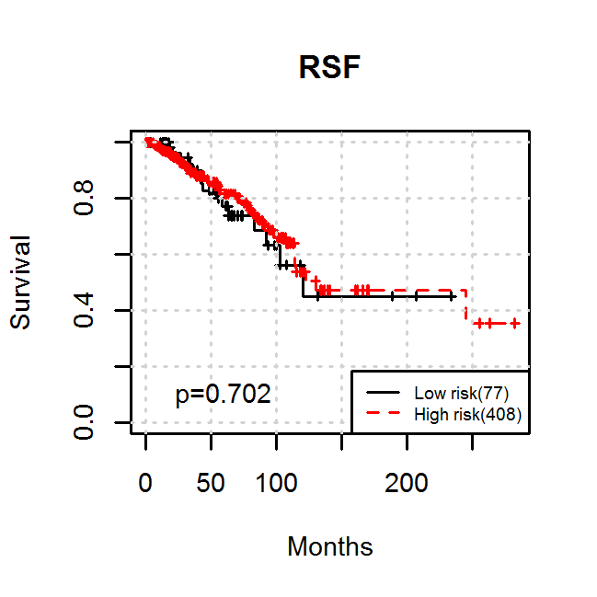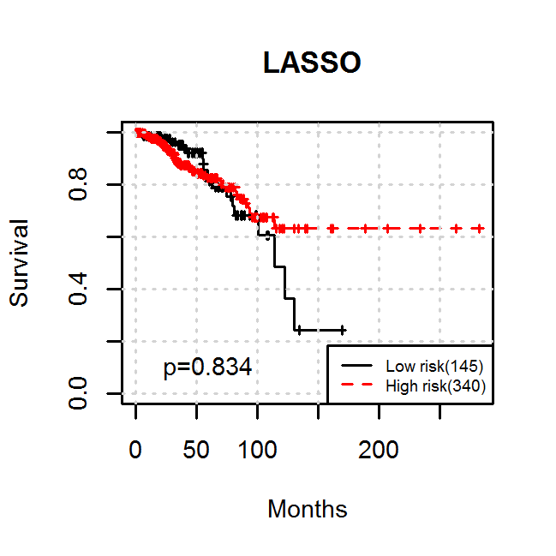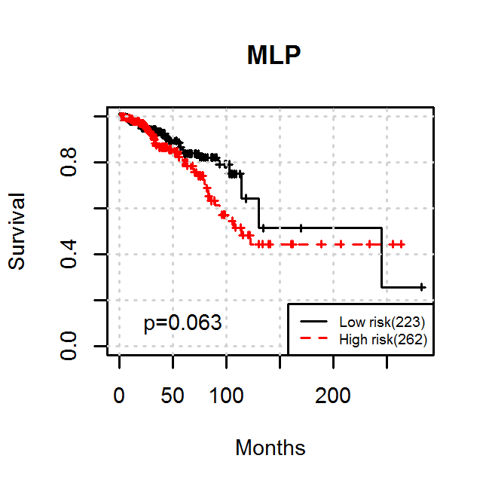
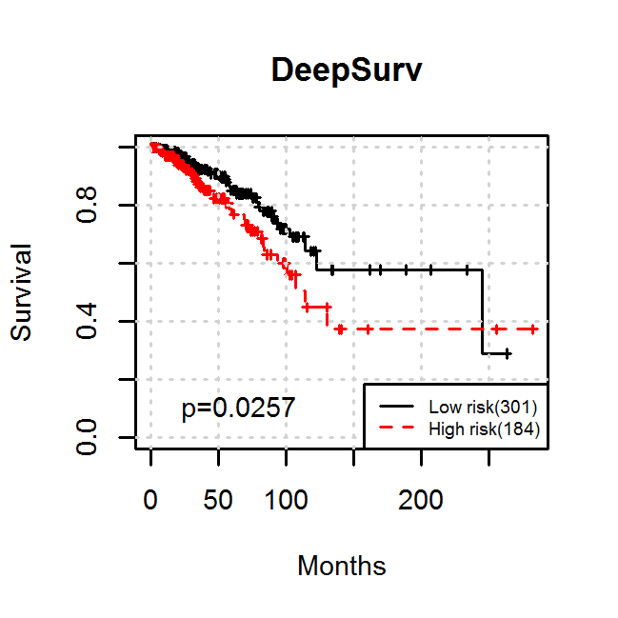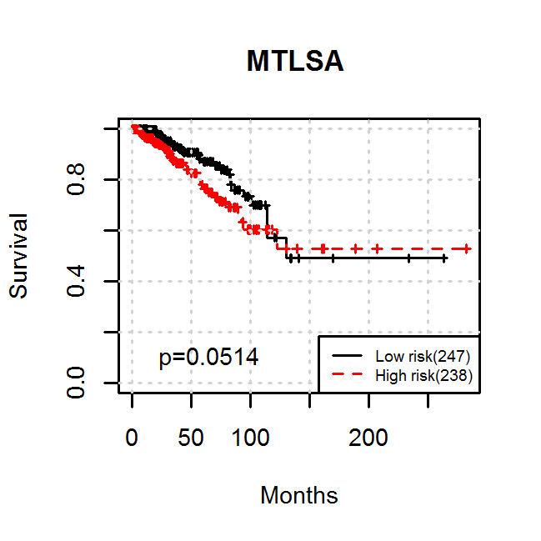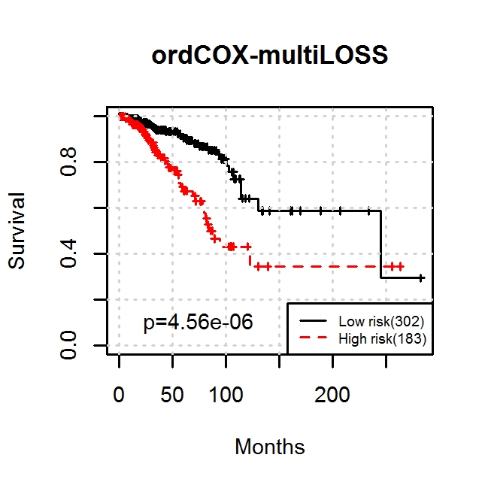
Figure 5. The survival curves by applying different methods.
As shown in Figure 5, the proposed prediction method (ML_ordCOX) achieves significantly superior stratification performance (log-rank test P =4.56e-06) when compared with the other methods (log-rank test P =0.702, 0.834, 0.063, 0.0257, and 0.0514 for RSF, LASSO, MLP, DeepSurv and MTLSA, respectively) on mRNA and methylation datasets, which shows the advantage of using auxiliary loss. In addition, it is worth noting that the proposed method could provide better prognostic prediction than the comparing methods, this is because our proposed model considers both the ordinal characteristics and the integrative patterns in survival analysis. Thus, its prognostic power is effectively improved.
  - Generalization performance comparison over independent validation sets
To further explore the effectiveness of the proposed method, we carry out experiments on two additional cancer types datasets, i.e., Glioma cohort (GBMLGG) and Pan-kidney cohort (KIPAN). The two datasets were also obtained from the Firehose. We select these two cohorts because they have a high number of cases which allows us to draw more valid inferences, and construct stronger comparisons to our breast cancer results. The GBMLGG datasets include 1129 samples for clinical data, 17184 gene expression features for mRNA sequencing data, and 20116 gene-level features for DNA methylation data. we obtained 563 instances that had both mRNA sequencing and DNA methylation data after merging and filtering. For GBMLGG datasets, by using lmQCM algorithm, we extracted 8 coexpressed features for methylation data and 21 coexpressed features for mRNA data. The KIPAN datasets contain 973 samples, 25055 gene expression features, and 20533 DNA methylation features. Similarly, we also extracted 656 instances that had both mRNA and DNA methylation data. For KIPAN, lmQCM algorithm yields 15 coexpressed features for methylation data and 10 coexpressed features for mRNA data. We compare the proposed method ML_ordCOX with the aforementioned five survival prediction methods on GBMLGG and KIPAN datasets. To ensure fairness, we still use the same feature set in all cross-validation tests.
Table 6. Performance comparisons among different survival prediction methods by C-index on GBMLGG and KIPAN datasets over ten-fold cross-validation (with standard deviations).
 | GBMLGG | KIPAN
The proposed method (ML_ordCOX) | 0.7975 (0.0201) | 0.7643 (0.0142)
MTLSA | 0.6883 (0.0193) | 0.7084 (0.0264)
DeepSurv | 0.7236 (0.0216) | 0.6947 (0.0173)
MLP | 0.6494 (0.0227) | 0.6545 (0.0363)
LASSO | 0.6235 (0.0147) | 0.6346 (0.0286)
RSF | 0.5932 (0.0278) | 0.6233 (0.0233)

Table 6 lists the performance comparisons between the proposed method, MTLSA, DeepSurv, MLP, Lasso, and RSF by the measurements of C-index on GBMLGG and KIPAN datasets. From Table 6, we can find that the proposed method ML_ordCOX achieved best performance on GBMLGG and KIPAN data. For GBMLGG, Compared with RSF, LASSO, MLP, DeepSurv, and MTLSA, the C-index of the developed approach ML_ordCOX is improved by 20.43%, 17.40%, 14.81%, 7.39% and 10.92%; and for KIPAN, the performance of ML_ordCOX has an increase of 14.10%, 12.97%, 10.98%, 6.96% and 5.59% in C-index respectively.
Hence, the test results demonstrate that the generalization capabilities of the developed approach are superior to those of the other five reported approaches. The good performance of independent test further demonstrates the effectiveness of the developed method for survival analysis of other cancer types.
- Conclusions
This study develops a survival analysis frame for breast cancer cases, considering cases’ ordinal survival information. Cross-validation experiments on the mRNA gene expression data, DNA methylation data and clinical data were carried out. Experimental results demonstrate the superiority of the proposed method over the existing RSF, Lasso, MLP, DeepSurv, and MTLSA methods. The good performances of the proposed method come from the use of the combined bidirectional LSTM predictor and ordinal information. Experimental results also show the importance of DNA methylation and gene expression signatures for breast cancer survival analysis. In this work, we have shown that dynamically combining an auxiliary task and adaptively adjusting the weights for the multiple tasks in an online manner can give a significant performance improvement for biLSTM Cox model network. The proposed method uses the idea that auxiliary tasks should provide a gradient update direction that helps to decrease the loss of the main task. In addition, we carry out experiments on Glioma cohort and Pan-kidney cohort. The good performance on the two additional cancers also demonstrates that our method is not limited to breast cancer and can be applied to other carcinoma types with many samples in TCGA.

References
Amiri, Z., et al. (2008) Assessment of gastric cancer survival: using an artificial hierarchical neural network, Pak J Biol Sci, 11, 1076-1084.
Anjum, S., et al. (2014) A BRCA1-mutation associated DNA methylation signature in blood cells predicts sporadic breast cancer incidence and survival, Genome medicine, 6, 47.
Chen, J.-M., et al. (2015) New breast cancer prognostic factors identified by computer-aided image analysis of HE stained histopathology images, Scientific reports, 5, 10690.
Cheng, J., et al. (2017) Integrative analysis of histopathological images and genomic data predicts clear cell renal cell carcinoma prognosis, Cancer research, 77, e91-e100.
Deng, M., et al. (2017) FirebrowseR: an R client to the Broad Institute’s Firehose Pipeline, Database, 2017.
Gulati, S., et al. (2014) Systematic evaluation of the prognostic impact and intratumour heterogeneity of clear cell renal cell carcinoma biomarkers, European urology, 66, 936-948.
Hochreiter, S. and Schmidhuber, J. (1997) Long short-term memory, Neural computation, 9, 1735-1780.
Ishwaran, H., et al. (2008) Random survival forests, The annals of applied statistics, 2, 841-860.
Jeong, H.-h., et al. (2015) Integrative network analysis for survival-associated gene-gene interactions across multiple genomic profiles in ovarian cancer, Journal of ovarian research, 8, 42.
Jiao, Y., Widschwendter, M. and Teschendorff, A.E. (2014) A systems-level integrative framework for genome-wide DNA methylation and gene expression data identifies differential gene expression modules under epigenetic control, Bioinformatics, 30, 2360-2366.
Katzman, J.L., et al. (2016) Deep survival: A deep cox proportional hazards network, stat, 1050, 2.
Katzman, J.L., et al. (2018) DeepSurv: personalized treatment recommender system using a Cox proportional hazards deep neural network, BMC medical research methodology, 18, 24.
Kim, D., et al. (2016) Using knowledge-driven genomic interactions for multi-omics data analysis: metadimensional models for predicting clinical outcomes in ovarian carcinoma, Journal of the American Medical Informatics Association, 24, 577-587.
Kim, H.L., et al. (2004) Using protein expressions to predict survival in clear cell renal carcinoma, Clinical Cancer Research, 10, 5464-5471.
Kim, S.Y., et al. (2018) Integrative pathway-based survival prediction utilizing the interaction between gene expression and DNA methylation in breast cancer, BMC medical genomics, 11, 68.
Kourou, K., et al. (2015) Machine learning applications in cancer prognosis and prediction, Computational and structural biotechnology journal, 13, 8-17.
Langfelder, P. and Horvath, S. (2008) WGCNA: an R package for weighted correlation network analysis, BMC bioinformatics, 9, 559.
Lee, E.T. and Wang, J. (2003) Statistical methods for survival data analysis. John Wiley & Sons.
Li, Y., et al. (2016) A multi-task learning formulation for survival analysis. Proceedings of the 22nd ACM SIGKDD International Conference on Knowledge Discovery and Data Mining. pp. 1715-1724.
Lin, D.Y., Wei, L.-J. and Ying, Z. (1993) Checking the Cox model with cumulative sums of martingale-based residuals, Biometrika, 80, 557-572.
Liu, G., et al. (2019) Bioimage-based Prediction of Protein Subcellular Location in Human Tissue with Ensemble Features and Deep Networks, IEEE/ACM transactions on computational biology and bioinformatics.
Lobo, I. (2008) Genomic imprinting and patterns of disease inheritance, Nature Education, 1, 5.
Papoudakis, G., Chatzidimitriou, K.C. and Mitkas, P.A. (2018) Deep reinforcement learning for Doom using unsupervised auxiliary tasks, arXiv preprint arXiv:1807.01960.
Ryall, S., Tabori, U. and Hawkins, C. (2017) A comprehensive review of paediatric low-grade diffuse glioma: pathology, molecular genetics and treatment, Brain tumor pathology, 34, 51-61.
Shao, W., et al. (2018) Ordinal multi-modal feature selection for survival analysis of early-stage renal cancer. International Conference on Medical Image Computing and Computer-Assisted Intervention. Springer, pp. 648-656.
Suzuki, H., et al. (2012) DNA methylation and microRNA dysregulation in cancer, Molecular oncology, 6, 567-578.
Sy, J.P. and Taylor, J.M. (2000) Estimation in a Cox proportional hazards cure model, Biometrics, 56, 227-236.
Tibshirani, R. (1997) The lasso method for variable selection in the Cox model, Statistics in medicine, 16, 385-395.
Tomczak, K., Czerwińska, P. and Wiznerowicz, M. (2015) The Cancer Genome Atlas (TCGA): an immeasurable source of knowledge, Contemporary oncology, 19, A68.
Wang, P., Li, Y. and Reddy, C.K. (2019) Machine learning for survival analysis: A survey, ACM Computing Surveys (CSUR), 51, 1-36.
Xiang, A., et al. (2000) Comparison of the performance of neural network methods and Cox regression for censored survival data, Computational statistics & data analysis, 34, 243-257.
Yang, X., et al. (2014) Gene body methylation can alter gene expression and is a therapeutic target in cancer, Cancer cell, 26, 577-590.
Yu, K.-H., et al. (2016) Predicting non-small cell lung cancer prognosis by fully automated microscopic pathology image features, Nature communications, 7, 12474.
Yuan, Y., et al. (2012) Quantitative image analysis of cellular heterogeneity in breast tumors complements genomic profiling, Science translational medicine, 4, 157ra143-157ra143.

